Recursive Query

🔄 What is a Recursive Query in DNS?
# Source: AI Source: Provided by: [Data Path: Persons Table -> ID Column: 1, Name_En Column: Motasem Essam] -> From: [ChatGPT] on [1/18/2026]
A recursive query is a DNS request in which the DNS client (your computer or browser) asks a DNS server (usually a recursive resolver) to fully resolve a domain name — meaning, it expects a complete final answer, not just a referral.
🧠 In a recursive query, the resolver does all the work to find the answer and returns just the result to you.

🔍 How It Works
# Source: AI Source: Provided by: [Data Path: Persons Table -> ID Column: 1, Name_En Column: Motasem Essam] -> From: [ChatGPT] on [1/18/2026]
Let’s say you type www.example.com into your browser:
- Your computer sends a recursive query to the DNS resolver.
- The resolver checks its cache:
  - ✅ If it has the IP → returns it.
  - ❌ If not → it:
    - Asks the Root DNS server
    - Then the TLD server for .com
    - Then the Authoritative server for example.com
- Once it finds the IP (e.g., 93.184.216.34), it sends it back to your computer.

📌 Characteristics of a Recursive Query
# Source: AI Source: Provided by: [Data Path: Persons Table -> ID Column: 1, Name_En Column: Motasem Essam] -> From: [ChatGPT] on [1/18/2026]
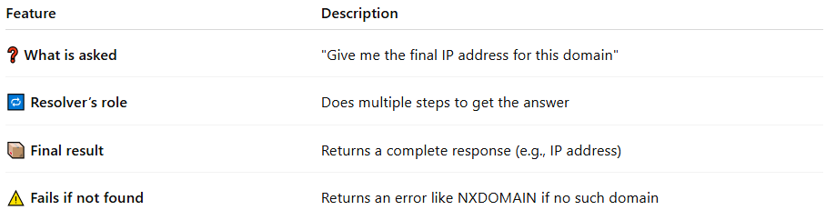

Feature | Description
❓ What is asked | "Give me the final IP address for this domain"
🔁 Resolver’s role | Does multiple steps to get the answer
📦 Final result | Returns a complete response (e.g., IP address)
⚠️ Fails if not found | Returns an error like NXDOMAIN if no such domain

🔁 Recursive vs Iterative Query
# Source: AI Source: Provided by: [Data Path: Persons Table -> ID Column: 1, Name_En Column: Motasem Essam] -> From: [ChatGPT] on [1/18/2026]
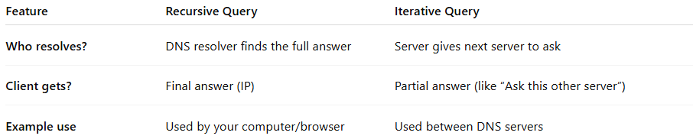

Feature | Recursive Query | Iterative Query
Who resolves? | DNS resolver finds the full answer | Server gives next server to ask
Client gets? | Final answer (IP) | Partial answer (like “Ask this other server”)
Example use | Used by your computer/browser | Used between DNS servers

✅ Summary
# Source: AI Source: Provided by: [Data Path: Persons Table -> ID Column: 1, Name_En Column: Motasem Essam] -> From: [ChatGPT] on [1/18/2026]
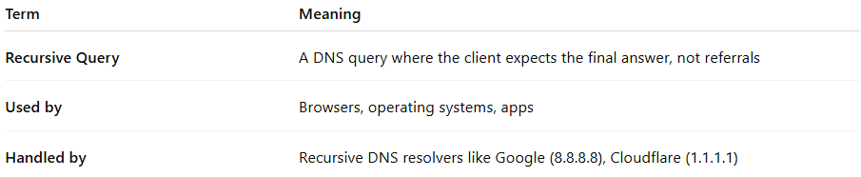

Term | Meaning
Recursive Query | A DNS query where the client expects the final answer, not referrals
Used by | Browsers, operating systems, apps
Handled by | Recursive DNS resolvers like Google (8.8.8.8), Cloudflare (1.1.1.1)

